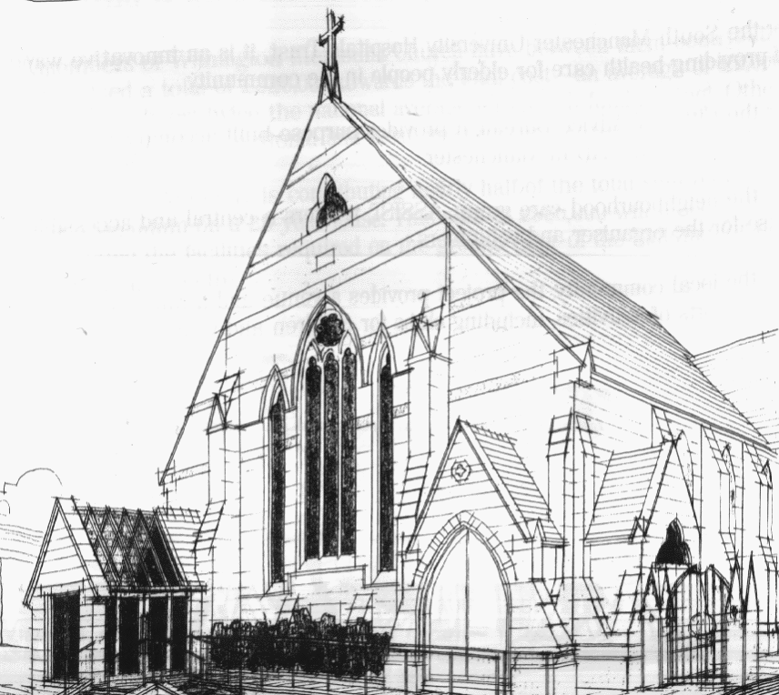
WITHINGTON METHODIST CHURCH
439 Wilmslow Road, Withington, Manchester M20 4AN
Telephone – 0161 445 0804
E-mail – office@withingtonmethodistchurch.org (Church Office)
Website – www.withingtonmethodistchurch.org

SUNDAY 17th AUGUST 2025

THOUGHT FOR THE WEEK
Do we praise God enough for the wonders of summer,
the bright flowers, the green shade, cool water and the clear sky?
Our praise leads us to repentance for the ways in which summer heat
is becoming a burden.
Our repentance leads us to reflect on our lifestyles and the ways in which we need to respond to climate change –
‘one of the principal challenges facing humanity in our day’

(Pope Francis)

Morning Worship – 10.45am – Led by Mrs. Christine Davis

Circuit Service (on Zoom) – 6.30pm – Led by Revd. Sharon Read

The Lectionary Readings for TODAY (Sunday 17th August) are –
ISAIAH 5 – v1 – 7 PSALM 80 – v1 – 2 & v8 – 19 HEBREWS 11 – v29 – HEBREWS 12 – v2
LUKE 12 – v49 – 56

PRAYER CONCERNS
All those caught up in conflict around the world: Israel, Gaza, Ukraine, Sudan, Yemen, Somalia, Syria, and those facing persecution,
Stella, Marlene’s son, Esther, Thandiwe and Peter, Lynne and Elycia, Lottie,
all those here who are struggling to pay their bills and facing long waits for hospital appointments,
all those friends still impacted by Covid-19, those members and friends unable to be with us

SUNDAY 24th AUGUST 2025

Morning Worship – 10.45am – including Holy Communion –

Conducted by Revd. Amanda Boon

There will be NO Circuit Service on Zoom next Sunday, August 24th

The Lectionary Readings for Next Sunday (August 24th) are –
JEREMIAH 1 – v4 – 10 PSALM 71 – v1 – 6 HEBREWS 12 – v18 – 29
LUKE 13 – v10 – 17

CIRCUIT SERVICE (ZOOM JOINING DETAILS)

If you wish to access this service,

please contact administrator@manchestermethodists.org.uk

for the Zoom joining details. Many thanks.

CHURCH ACTIVITIES

Needles and Yarns –
A warm invitation is extended to all to Needles and Yarns, which continues this coming
Friday, August 22nd from 10.30am – 12.00noon in the Church Foyer.
The group will continue to meet at these times each Friday going forward.
Refreshments will be provided. Many thanks.

Circuit Welcome Service –
Everyone is warmly invited to the Welcome Service for our new Superintendent Minister,
the Revd. Dr. Joanne Cox-Darling, on Saturday 30th August at 6.30pm.
The service will be held at Whalley Range Methodist Church
(51 Withington Road, Manchester, M16 7EX), and there will be refreshments
before the service.
The service will be available on Zoom for those unable to attend in person –
the joining code will be circulated shortly prior to the event. Many thanks.


Book Club
Next Meeting – Monday 1st September at 7.30pm
This month we will be reviewing ‘The Salt Path’ by Raynor Winn
New members always welcome!

New Methodist Year Service – Tuesday 2nd September -
Greetings
We are writing to invite you to a Service at Methodist Central Hall, Manchester
(M1 1JQ) to mark the beginning of a new Methodist Year and at which we will welcome
The President and The Vice-President of The Methodist Conference to Manchester.
The service will include a celebration of Central Hall Manchester being recognised as a
Church of Sanctuary.
The service will take place on Tuesday 2nd September and will begin at 11.00am.
After the service in Main Hall there will be a buffet lunch.
It would be wonderful if you were able to join us at the service and the lunch.
So that we can cater accordingly, please register here – https://bit.ly/NewConnexionalYear2025
We look forward to hearing from you.
Best regards
Rev Ian Rutherford, Deacon Jenny Jones, Karen Attaway
The Ministry Team, Methodist Central Hall, Manchester

