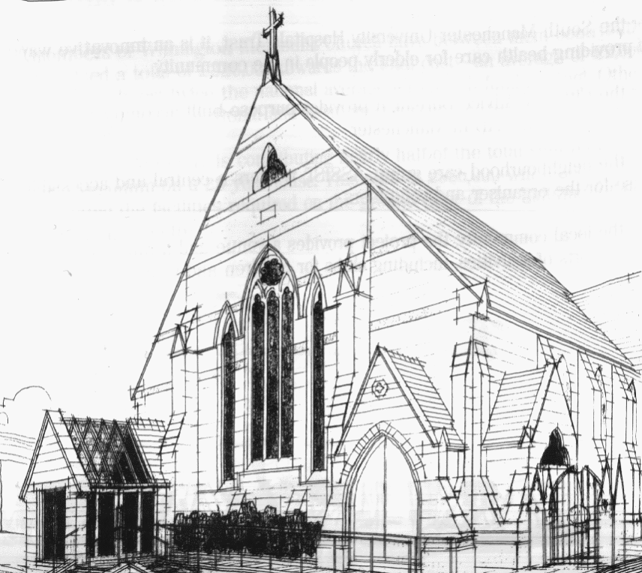
WITHINGTON METHODIST CHURCH
439 Wilmslow Road, Withington, Manchester M20 4AN
Telephone – 0161 445 0804
Minister – Revd. Dr. Caroline Wickens
E-mail – office@withingtonmethodistchurch.org (Church Office)
minister@withingtonmethodistchurch.org (Revd. Dr. Caroline Wickens)
Website – www.withingtonmethodistchurch.org

SUNDAY 20th APRIL 2025
EASTER SUNDAY

THOUGHT FOR THE WEEK
The Easter message tells us that our enemies, sin and death, are beaten.
Ultimately they can no longer start mischief.
They still behave as though the game were not decided, the battle not fought;
we must still reckon with them,
but fundamentally we must cease to fear them any more.
(Karl Barth)

Morning Worship – 10.45am – including Holy Communion –

Conducted by Revd. Amanda Boon

Followed by Refreshments

Circuit Service (on Zoom) – 6.30pm – Led by Revd. Dr. Caroline Wickens

The Lectionary Readings for TODAY (Sunday 20th April) are –
ACTS 10 – v34 – 43 PSALM 118 – v1 – 2 & v14 – 24 1 CORINTHIANS 15 – v19 – 26
JOHN 20 – v1 – 18

PRAYER CONCERNS
We remember especially in our prayers at this time the family and friends of
Brenda Weightman – Brenda passed away last Saturday
All those caught up in conflict around the world: Israel, Gaza, Ukraine, Sudan, Yemen, Somalia, Syria, and those facing persecution,
everyone affected and impacted by the recent earthquake in Myanmar,
Esther, Stella, Lynne and Elycia, Lottie,
all those here who are struggling to pay their bills and facing long waits for
hospital appointments,
all those friends still impacted by Covid-19, those members and friends unable to be with us

SUNDAY 27th APRIL 2025

Morning Worship – 10.45am – Led by Mrs. Pamela Sewart

Circuit Service (on Zoom) – 6.30pm – Led by Revd. Catharine Hughes

The Lectionary Readings for Next Sunday (April 27th) are –
ACTS 5 – v27 – 32 PSALM 118 – v14 – 29 REVELATION 1 – v4 – 8
JOHN 20 – v19 – 31

CIRCUIT SERVICE (ZOOM JOINING DETAILS)

https://zoom.us/j/92204599032?pwd=Tzg0SU9xcVZEZFNQK0FnYnNKWjlUQT09

Meeting ID: 922 0459 9032 Passcode: 1901

CHURCH ACTIVITIES

Needles and Yarns –
A warm invitation is extended to all to Needles and Yarns, which continues this coming
Friday, April 25th from 10.30am – 12.00noon in the Church Foyer.
The group will continue to meet at these times each Friday going forward.
Refreshments will be provided. Many thanks.

WMC – PLANS FOR THE FUTURE
Have your say!
In November 2019 Revd. Dr. Caroline, as Circuit Superintendent, produced a document entitled ‘Towards a Missional Strategy for the Use of Withington Methodist Church Building.’ Key characteristics of the local community, the current use of our building and suggestions for why and how we further develop the usage were considered.
Then came the pandemic and for some time all activity, including in person worship, ceased.
As months passed we slowly picked ourselves up and church activities, commercial lettings and our partner groups – Assist, Heart Help and Head Forward – returned. But although we welcomed some new faces here , not all pre pandemic users came back. There were significantly fewer worshippers on a Sunday morning (circuit evening worship remained on zoom), though we were well in touch with many who were unable to attend in person, and
we no longer had some of our previous regular church run groups and lettings,
albeit some new ventures did start up.
In 2021 we began again discussions about the way forward, culminating in an Away Day on 30th October at the Chapel in the Field in Sinderland. This was attended by a relatively small group of members in person and online. We invited Abigail Parr from Transforming Churches and Communities (TCC) to summarize our ideas and provide an objective assessment of the options for the future of WMC, focussed primarily on the building itself. Consideration was given to the past evidence that past rejuvenation projects had not achieved their aims, the workload that was falling on the current Stewards’ team and small Management committee, and the desire to move forward.
Abi produced a report which suggested 5 options to consider, and in March 2022 we examined this in a meeting led by Caroline at WMC.
Since then our energy bills, maintenance and staffing costs have inevitably increased. Additionally a significant loss of income arose when the lease with the NHS ended in 2023 and has not been renewed. So a new contract has had to be drawn up with Heart Help and
Head Forward who are managing to balance their books by paying the church a considerably reduced rent.
Thus since 2021 we have been continuing much as before, but with financial implications following our Quinquennial inspection and report in December 2024, the Church Council recommend that we should revisit the discussion regarding our future.
We would strongly encourage those who are concerned about these issues,
to attend a meeting at WMC on Saturday 10th May from 10.00am – 3.00pm.
Refreshments and lunch will be provided. We look forward to seeing you there!


Book Club
Next Meeting – Monday 9th June at 7.30pm
This month we will be discussing ‘Conclave’ by Robert Harris
New members always welcome!

