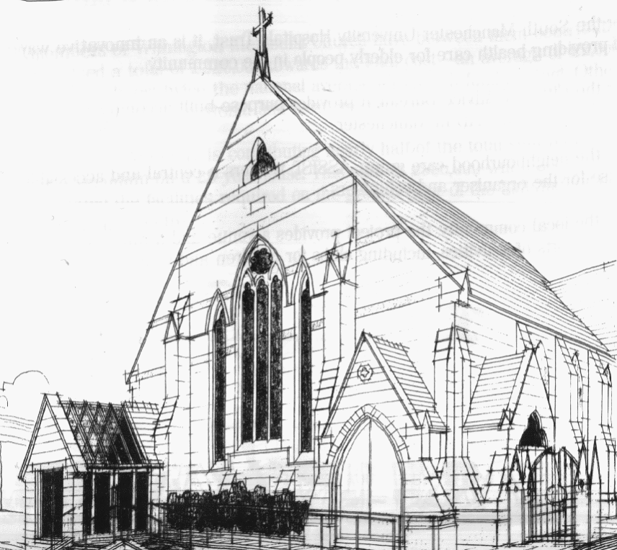
WITHINGTON METHODIST CHURCH
439 Wilmslow Road, Withington, Manchester M20 4AN
Telephone – 0161 445 0804
Minister – Revd. Catharine Hughes
E-mail – office@withingtonmethodistchurch.org (Church Office)
Website – www.withingtonmethodistchurch.org

SUNDAY 28th SEPTEMBER 2025

THOUGHT FOR THE WEEK
Harvest
The earth is the Lord’s and all who dwell there,
The earth is the Lord’s and all the creatures who make their homes there,
The earth is the Lord’s and we have been gifted the chance to nurture it.
Let us join together to celebrate the beauty of the land,
The kaleidoscope of people,
The variety of abundance.
Let us join in with nature’s anthem and proclaim God’s good and holy name.
Amen.

[from All We Can - Harvest resources, 2025]

Morning Worship – 10.45am – at Levenshulme Methodist Church –

Led by Revd. Amanda Boon

TODAY, September 28th, we will be joining with our friends at
Levenshulme Methodist Church (824 Stockport Road, Levenshulme, M19 3AW)
for their Harvest Festival Morning Worship at 10.45am, which will be led by
Revd. Amanda Boon

There will be NO Morning Worship here at Withington TODAY

Circuit Service (on Zoom) – 6.30pm – Led by Revd. Catharine Hughes

The Lectionary Readings for TODAY (Sunday 28th September) are –
JEREMIAH 32 – v1 – 3a & v6 – 15 PSALM 91 – v1 – 6 & v14 – 16 1 TIMOTHY 6 – v6 – 19 LUKE 16 – v19 – 31

PRAYER CONCERNS
All those caught up in conflict around the world: Israel, Gaza, Ukraine, Sudan, Yemen, Somalia, Syria, and those facing persecution,
Janice, Stella, Marlene’s son, Esther, Thandiwe and Peter, Lynne and Elycia, Lottie, the family and friends of Eric Leary,
all those here who are struggling to pay their bills and facing long waits for hospital appointments,
all those friends still impacted by Covid-19, those members and friends unable to be with us

SUNDAY 5th OCTOBER 2025

Morning Worship – 10.45am – Harvest Festival Service –

Local Arrangement

Circuit Service (on Zoom) – 6.30pm – including Holy Communion –

Conducted by Revd. Dr. Jo Cox-Darling

The Lectionary Readings for Next Sunday (October 5th) are –
LAMENTATIONS 1 – v1 – 6 PSALM 137 2 TIMOTHY 1 – v1 – 14 LUKE 17 – v5 – 10

CIRCUIT SERVICE (ZOOM JOINING DETAILS)

SEPTEMBER 28th 2025

https://zoom.us/j/4307099384?pwd=Q0pDN3R4TW1heExWc2l4eVA5WHRYQT09

Meeting ID: 430 709 9384 Passcode: 240120

CHURCH ACTIVITIES

Needles and Yarns –
A warm invitation is extended to all to Needles and Yarns, which continues this coming
Friday, October 3rd from 10.30am – 12.00noon in the Church Foyer.
The group will continue to meet at these times each Friday going forward.
Refreshments will be provided. Many thanks.

WMC Harvest Service –
On Sunday 5th October, Withington Methodist Church will be holding a Harvest Service at 10.45am.
In our usual tradition, during this service we receive any donations of non-perishable food to donate to the Fallowfield and Withington Food Bank.
If anyone is able to donate to this service, or beforehand via drop off at the church office,
it would be greatly appreciated.
If you would like more information on the work of the foodbank and how you might be able to partner with them more closely, please contact them via: info@fallowfieldwithington.foodbank.org.uk Many thanks.


Book Club
Next Meeting – Monday 6th October at 7.30pm
This month we are reading ‘Three Men In A Boat’ by Jerome K Jerome
New members always welcome!

Forthcoming Events –

Christian Aid – ‘Powered by Hope’ – Saturday 4th October – 10.00am – 4.30pm –
Friends’ Meeting House, 6 Mount Street, Manchester, M2 5NS –
Join us for a day to fuel your faith, fill your cup with hope and inspire action. Whether you’re curious about putting faith into action, a seasoned action taker or just want to pray with your legs, then this event is for you.

Theos Annual Lecture 2025 – Thursday 9th October – 7.00pm (doors at 6.30pm) –
Methodist Central Hall, Central Buildings, Oldham Street, Manchester, M1 1JQ –
With Mayor of Greater Manchester – Andy Burnham
The Theos Annual Lecture is an opportunity for a respected speaker to deliver a significant intervention on his or her chosen topic related, broadly, to faith and ethics in public life. It is, in effect, a platform for a public intellectual to do what Theos was founded to do, i.e. to tell a better story about faith – better in the sense of more accurate, but also better in the sense of more appealing, more attractive, more winsome.

Methodist Women in Britain (MWiB) Manchester and Stockport Area
Autumn Gathering – Saturday 11th October –
10.30am – 3.00pm – Droylsden Methodist Church (Albert Street, M43 7BA) –
Speaker – Deacon Jenny Jones – ‘Our Story Our Song, Methodist Central Hall, Manchester,
The past, the present and the future’. Coffee served from 10.00am.

Fruit-full – A Celebration of Creation and Community –
Saturday 11th October – 2.00pm – 4.00pm – St. Chad’s Ladybarn Church and Hall –
Green Fair with Levenshulme Library of Things, samosas, fresh fruit and smoothies with Withington Fruit and Veg, Fair Trade stall and Fair Trade chocolate fountain,
children’s activities, walk a labyrinth and other stalls and activities

For further information on any of these events, please see the posters on the church notice boards or ask the church stewards. Many thanks.

