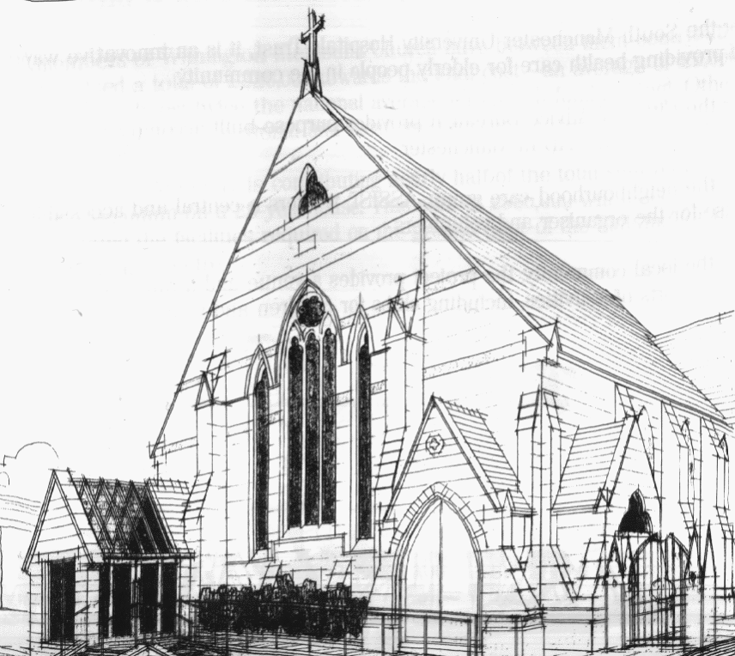
WITHINGTON METHODIST CHURCH
439 Wilmslow Road, Withington, Manchester M20 4AN
Telephone – 0161 445 0804
Minister – Revd. Dr. Caroline Wickens
E-mail – office@withingtonmethodistchurch.org (Church Office)
minister@withingtonmethodistchurch.org (Revd. Dr. Caroline Wickens)
Website – www.withingtonmethodistchurch.org

SUNDAY 25th MAY 2025
ALDERSGATE SUNDAY

THOUGHT FOR THE WEEK
Look, I am making all things new.
Revive us, Lord, in all we do.
Reach into our hearts, through Spirit, wind and flame.
Renew us, Lord, in word and deed.
In us build a new creation.
May our hearts be strangely warmed, that we might grow and change together.

On Aldersgate Sunday, Methodists remember God’s life-changing
gift of the Spirit to John and Charles Wesley.

Morning Worship – 10.45am – at Levenshulme Methodist Church –

Led by Mr. Nick Palfreyman

TODAY, we will be joining with our friends at Levenshulme Methodist Church
(824 Stockport Road, Levenshulme, M19 3AW) for Morning Worship at 10.45am,
which will be led by Mr. Nick Palfreyman

There will be NO Morning Worship here at Withington TODAY

Circuit Service (on Zoom) – 6.30pm – Led by Dr. Keith Paver

The Lectionary Readings for TODAY (Sunday 25th May) are –
ACTS 16 – v9 – 15 PSALM 67 REVELATION 21 – v10 & v22 – REVELATION 22 – v5
JOHN 14 – v23 – 29

PRAYER CONCERNS
All those caught up in conflict around the world: Israel, Gaza, Ukraine, Sudan, Yemen, Somalia, Syria, and those facing persecution,
Thandiwe and Peter, Esther, Lynne and Elycia, Lottie,
all those here who are struggling to pay their bills and facing long waits for hospital appointments,
all those friends still impacted by Covid-19, those members and friends unable to be with us

SUNDAY 1st JUNE 2025

Morning Worship – 10.45am – Led by Mr. Nick Palfreyman

Circuit Service (on Zoom) – 6.30pm – including Holy Communion –

Conducted by Revd. Paul Welch

The Lectionary Readings for Next Sunday (June 1st) are –
ACTS 16 – v16 – 34 PSALM 97 REVELATION 22 – v12 – 14, v16 – 17 & v20 – 21
JOHN 17 – v20 – 26

CIRCUIT SERVICE (ZOOM JOINING DETAILS)

If you wish to access this service,

please contact Rev. Dr. Caroline Wickens via manchestermethodists.org.uk

Many thanks

CHURCH ACTIVITIES

Needles and Yarns –
A warm invitation is extended to all to Needles and Yarns, which continues this coming
Friday, May 30th from 10.30am – 12.00noon in the Church Foyer.
The group will continue to meet at these times each Friday going forward.
Refreshments will be provided. Many thanks.


Book Club
Next Meeting – Monday 9th June at 7.30pm
This month we will be discussing ‘Conclave’ by Robert Harris
New members always welcome!

