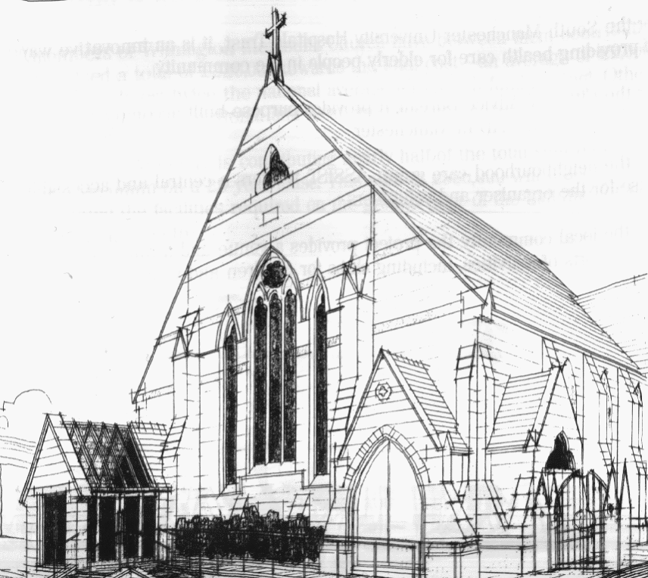
WITHINGTON METHODIST CHURCH
439 Wilmslow Road, Withington, Manchester M20 4AN
Telephone – 0161 445 0804
Minister – Revd. Dr. Caroline Wickens
E-mail – office@withingtonmethodistchurch.org (Church Office)
minister@withingtonmethodistchurch.org (Revd. Dr. Caroline Wickens)
Website – www.withingtonmethodistchurch.org

SUNDAY 3rd AUGUST 2025

THOUGHT FOR THE WEEK
in this week the world remembers Hiroshima
Hear my voice, for it is the voice of the victims of all wars and violence among individuals and nations;
Hear my voice, for it is the voice of all children who suffer and will suffer when people put their faith in weapons and war;
Hear my voice when I beg you to instil into the hearts of all human beings the wisdom of peace, the strength of justice and the joy of fellowship;
O God, hear my voice and grant unto the world your everlasting peace.

Pope John Paul II, prayer at the Hiroshima Memorial, 1981

Morning Worship – 10.45am – at Levenshulme Methodist Church –

Led by Dr. Keith Paver

TODAY, we will be joining with our friends at Levenshulme Methodist Church
(824 Stockport Road, Levenshulme, M19 3AW) for Morning Worship at 10.45am, which will be led by Dr. Keith Paver

There will be NO Morning Worship here at Withington TODAY

Circuit Service (on Zoom) – 6.30pm – Led by Revd. Paul Welch

The Lectionary Readings for TODAY (Sunday 3rd August) are –
HOSEA 11 – v1 – 11 PSALM 107 – v1 – 9 & v43 COLOSSIANS 3 – v1 – 11 LUKE 12 – v13 – 21

PRAYER CONCERNS
All those caught up in conflict around the world: Israel, Gaza, Ukraine, Sudan, Yemen, Somalia, Syria, and those facing persecution,
the family and friends of Betty Priestley, Stella, Marlene’s son, Esther, Thandiwe and Peter, Lynne and Elycia, Lottie,
all those here who are struggling to pay their bills and facing long waits for hospital appointments,
all those friends still impacted by Covid-19, those members and friends unable to be with us

SUNDAY 10th AUGUST 2025

Morning Worship – 10.45am – Led by Miss. Janet Green

Circuit Service (on Zoom) – 6.30pm – District Service

The Lectionary Readings for Next Sunday (August 10th) are –
ISAIAH 1 – v1 & v10 – 20 PSALM 50 – v1 – 8 & v22 – 23
HEBREWS 11 – v1 – 3 & v8 – 16 LUKE 12 – v32 – 40

CIRCUIT SERVICE (ZOOM JOINING DETAILS)

SUNDAY 3rd AUGUST 2025

https://us06web.zoom.us/j/89544741668?pwd=Qb4N8PfZrBbDXMZZk0t4vsD4XPEwqw.1

Meeting ID: 895 4474 1668 Passcode: 217112

CHURCH ACTIVITIES


Book Club
Next Meeting – Monday 4th August at 7.30pm
This month we are reading ‘True Crime Story’ by Joseph Knox
New members always welcome!

Needles and Yarns –
A warm invitation is extended to all to Needles and Yarns, which continues this coming
Friday, August 8th from 10.30am – 12.00noon in the Church Foyer.
The group will continue to meet at these times each Friday going forward.
Refreshments will be provided. Many thanks.

