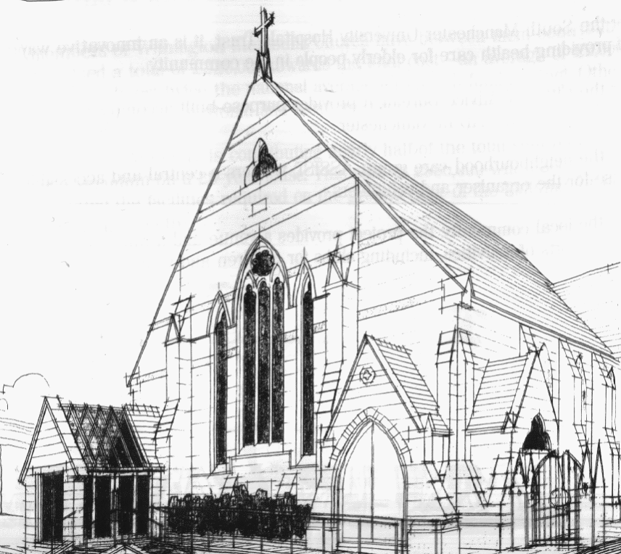
WITHINGTON METHODIST CHURCH

439 Wilmslow Road, Withington, Manchester M20 4AN
Telephone – 0161 445 0804
Minister – Revd. Catharine Hughes
E-mail – office@withingtonmethodistchurch.org (Church Office)
Website – www.withingtonmethodistchurch.org

SUNDAY 26th OCTOBER 2025
BIBLE SUNDAY

THOUGHT FOR THE WEEK
Grant us the grace, O God, to surrender the grievance that separates
and the forgiveness that is withheld.
Assure us that no sin is so great that it cannot be confessed, no wound so deep it cannot be healed, and no sinner so lost that grace cannot bring them home.

William Booth (1829-1912)

Morning Worship – 10.45am – Led by Revd. Dr. Jo Cox-Darling

We extend an especially warm welcome today to our friends from
Levenshulme Methodist Church, who are joining us for Morning Worship

Circuit Service (on Zoom) – 6.30pm – Led by Revd. Catharine Hughes

The Lectionary Readings for TODAY (Sunday 26th October) are –
JOEL 2 – v23 – 32 PSALM 65 2 TIMOTHY 4 – v6 – 8 & v16 – 18 LUKE 18 – v9 – 14

PRAYER CONCERNS
All those caught up in conflict around the world: Israel, Gaza, Ukraine, Sudan, Yemen, Somalia, Syria, and those facing persecution,
Andrew, Siân, Amy, Megan and family, Rawan, Toby and the Kouzali family, Jenny and Peter, Jamshaid (Promilla’s brother), Janice, Stella, Marlene and family, Esther, Thandiwe and Peter,
Lynne and Elycia,
all those here who are struggling to pay their bills and facing long waits for hospital appointments,
all those friends still impacted by Covid-19, those members and friends unable to be with us

SUNDAY 2nd NOVEMBER 2025
ALL SAINTS

Morning Worship – 10.45am – Led by Ms. Eva Manley

Circuit Service (on Zoom) – 6.30pm – including Holy Communion –
Conducted by Revd. Catharine Hughes

The Lectionary Readings for Next Sunday (November 2nd) are –
DANIEL 7 – v1 – 3 & v15 – 18 PSALM 149 EPHESIANS 1 – v11 – 23 LUKE 6 – v20 – 31
CIRCUIT SERVICE (ZOOM JOINING DETAILS)
OCTOBER 26th 2025

Https://zoom.us/j/4307099384?pwd=Q0pDN3R4TW1heExWc2l4eVA5WHRYQT09

Meeting ID: 430 709 9384 Passcode: 240120

CHURCH ACTIVITIES

Thank you to everyone who supported me (both with prayer and money)
in my Shine Night Walk on 10 October.
My sister and I have raised over £1000 for Cancer Research between us -
way above our original target.
We are both overwhelmed by the generosity of family and friends.
Rev Catharine

Needles and Yarns –
A warm invitation is extended to all to Needles and Yarns, which continues this coming
Friday, October 31st from 10.30am – 12.00noon in the Church Foyer.
The group will continue to meet at these times each Friday going forward.
Refreshments will be provided. Many thanks.


Book Club
Next Meeting – Monday 3rd November at 7.30pm
This month we are reading ‘The Outsider’ by Albert Camus
New members always welcome!

