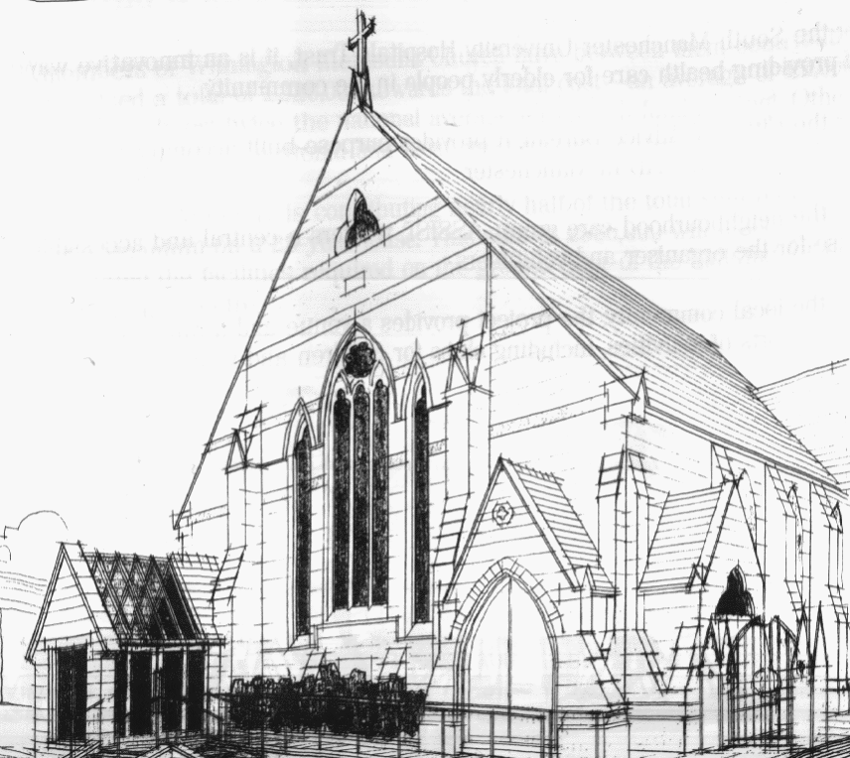
WITHINGTON METHODIST CHURCH
439 Wilmslow Road, Withington, Manchester M20 4AN
Telephone – 0161 445 0804
Minister – Revd. Dr. Caroline Wickens
E-mail – office@withingtonmethodistchurch.org (Church Office)
minister@withingtonmethodistchurch.org (Revd. Dr. Caroline Wickens)
Website – www.withingtonmethodistchurch.org

SUNDAY 1st JUNE 2025

THOUGHT FOR THE WEEK
Where is Jesus now?
The story of the Ascension tells us that he is everywhere –
‘no longer bound to distant years in Palestine, but saving, healing, here and now,
and touching every place and time’

(Brian Wren, StF 297)

Morning Worship – 10.45am – Led by Mr. Nick Palfreyman

We extend an especially warm welcome today to our friends from
Levenshulme Methodist Church, who are joining us for Morning Worship

Circuit Service (on Zoom) – 6.30pm – including Holy Communion –

Conducted by Revd. Paul Welch

The Lectionary Readings for TODAY (Sunday 1st June) are –
ACTS 16 – v16 – 34 PSALM 97 REVELATION 22 – v12 – 14, v16 – 17 & v20 – 21
JOHN 17 – v20 – 26

PRAYER CONCERNS
All those caught up in conflict around the world: Israel, Gaza, Ukraine, Sudan, Yemen, Somalia, Syria, and those facing persecution,
Thandiwe and Peter, Esther, Lynne and Elycia, Lottie,
all those here who are struggling to pay their bills and facing long waits for hospital appointments,
all those friends still impacted by Covid-19, those members and friends unable to be with us

SUNDAY 8th JUNE 2025

PENTECOST SUNDAY

Morning Worship – 10.45am – including Holy Communion –

Conducted by Revd. Dr. Caroline Wickens

Circuit Service (on Zoom) – 6.30pm – District Service

The Lectionary Readings for Next Sunday (June 8th) are –
ACTS 2 – v1 – 21 PSALM 104 – v24 – 34 & v35b ROMANS 8 – v14 – 17
JOHN 14 – v8 – 17 (v25 – 27)

CIRCUIT SERVICE (ZOOM JOINING DETAILS)

If you wish to access this service,

please contact Rev. Dr. Caroline Wickens via manchestermethodists.org.uk

Many thanks

CHURCH ACTIVITIES

Needles and Yarns –
A warm invitation is extended to all to Needles and Yarns, which continues this coming
Friday, June 6th from 10.30am – 12.00noon in the Church Foyer.
The group will continue to meet at these times each Friday going forward.
Refreshments will be provided. Many thanks.


Book Club
Next Meeting – Monday 9th June at 7.30pm
This month we will be discussing ‘Conclave’ by Robert Harris
New members always welcome!

