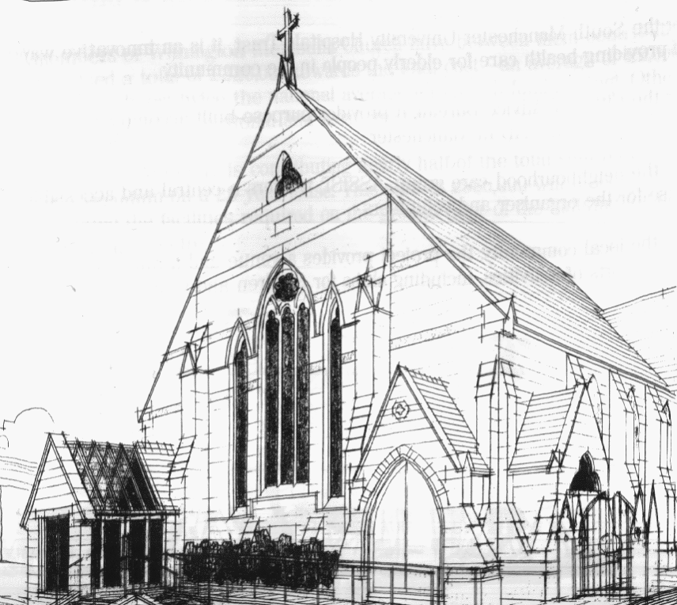
WITHINGTON METHODIST CHURCH
439 Wilmslow Road, Withington, Manchester M20 4AN
Telephone – 0161 445 0804
E-mail – office@withingtonmethodistchurch.org (Church Office)
Website – www.withingtonmethodistchurch.org

SUNDAY 10th AUGUST 2025

THOUGHT FOR THE WEEK
The Gospel reading makes an astute connection between treasure and our emotions, between what we value and the values that drive us.
The challenge is to understand what real treasure is. Real treasure comes from God. This is treasure that will last forever. Yet, it can be found right here, right now;
and we find it by looking at what God is doing all around us
and joining in the work of his kingdom.

Roots on the Web, August 2022

Morning Worship – 10.45am – Led by Miss. Janet Green

Circuit Service (on Zoom) – 6.30pm – District Service

The Lectionary Readings for TODAY (Sunday 10th August) are –
ISAIAH 1 – v1 & v10 – 20 PSALM 50 – v1 – 8 & v22 – 23
HEBREWS 11 – v1 – 3 & v8 – 16 LUKE 12 – v32 – 40

PRAYER CONCERNS
All those caught up in conflict around the world: Israel, Gaza, Ukraine, Sudan, Yemen, Somalia, Syria, and those facing persecution,
the family and friends of Betty Priestley, Stella, Marlene’s son, Esther, Thandiwe and Peter, Lynne and Elycia, Lottie,
all those here who are struggling to pay their bills and facing long waits for hospital appointments,
all those friends still impacted by Covid-19, those members and friends unable to be with us

SUNDAY 17th AUGUST 2025

Morning Worship – 10.45am – Led by Mrs. Christine Davis

Circuit Service (on Zoom) – 6.30pm – Led by Revd. Sharon Read

The Lectionary Readings for Next Sunday (August 17th) are –
ISAIAH 5 – v1 – 7 PSALM 80 – v1 – 2 & v8 – 19 HEBREWS 11 – v29 – HEBREWS 12 – v2
LUKE 12 – v49 - 56

CIRCUIT SERVICE (ZOOM JOINING DETAILS)

SUNDAY 10th AUGUST 2025

Meeting ID: 979 2312 5645

Passcode: 543701

CHURCH ACTIVITIES

Needles and Yarns –
A warm invitation is extended to all to Needles and Yarns, which continues this coming
Friday, August 15th from 10.30am – 12.00noon in the Church Foyer.
The group will continue to meet at these times each Friday going forward.
Refreshments will be provided. Many thanks.


Book Club
Next Meeting – Monday 1st September at 7.30pm
This month we will be reviewing ‘The Salt Path’ by Raynor Winn
New members always welcome!

New Methodist Year Service – Tuesday 2nd September -
Greetings
We are writing to invite you to a Service at Methodist Central Hall, Manchester
(M1 1JQ) to mark the beginning of a new Methodist Year and at which we will welcome
The President and The Vice-President of The Methodist Conference to Manchester.
The service will include a celebration of Central Hall Manchester being recognised as a
Church of Sanctuary.
The service will take place on Tuesday 2nd September and will begin at 11.00am.
After the service in Main Hall there will be a buffet lunch.
It would be wonderful if you were able to join us at the service and the lunch.
So that we can cater accordingly, please register here – https://bit.ly/NewConnexionalYear2025
We look forward to hearing from you.
Best regards
Rev Ian Rutherford, Deacon Jenny Jones, Karen Attaway
The Ministry Team, Methodist Central Hall, Manchester

