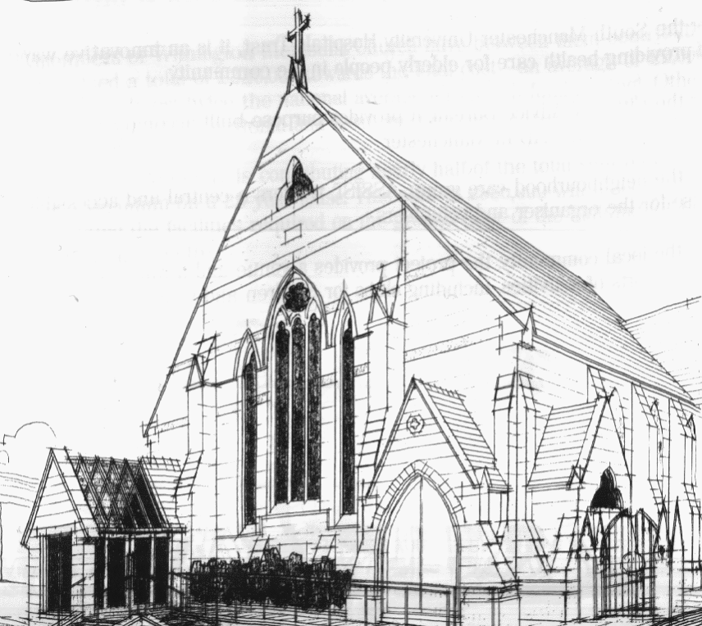
WITHINGTON METHODIST CHURCH
439 Wilmslow Road, Withington, Manchester M20 4AN
Telephone – 0161 445 0804
Minister – Revd. Dr. Caroline Wickens
E-mail – office@withingtonmethodistchurch.org (Church Office)
minister@withingtonmethodistchurch.org (Revd. Dr. Caroline Wickens)
Website – www.withingtonmethodistchurch.org

SUNDAY 4th MAY 2025
VOCATIONS SUNDAY

THOUGHT FOR THE WEEK
“Vocation means what we are called by God to be and do.
For some, this is a specific calling to a particular kind of ministry,
in or on behalf of, the Church.
For others, it could mean serving God through faithful discipleship in everyday life.”

From the Methodist website, www.methodist.org.uk

Morning Worship – 10.45am – Led by Ms. Mercy Drewett

We extend an especially warm welcome today to our friends from
Levenshulme Methodist Church, who are joining us for Morning Worship

Circuit Service (on Zoom) – 6.30pm – including Holy Communion –

Conducted by Revd. Paul Welch

The Lectionary Readings for TODAY (Sunday 4th May) are –
ACTS 9 – v1 – 6 (v7 – 20) PSALM 30 REVELATION 5 – v11 – 14 JOHN 21 – v1 – 19

PRAYER CONCERNS
All those caught up in conflict around the world: Israel, Gaza, Ukraine, Sudan, Yemen, Somalia, Syria, and those facing persecution,
the family and friends of Brenda Weightman, Esther, Stella, Lynne and Elycia, Lottie,
all those here who are struggling to pay their bills and facing long waits for hospital appointments,
all those friends still impacted by Covid-19, those members and friends unable to be with us

SUNDAY 11th MAY 2025

CHRISTIAN AID WEEK

Morning Worship – 10.45am – including Holy Communion –

Conducted by Revd. Dr. Caroline Wickens

Circuit Service (on Zoom) – 6.30pm – Led by Revd. Dr. Caroline Wickens

The Lectionary Readings for Next Sunday (May 11th) are –
ACTS 9 – v36 – 43 PSALM 23 REVELATION 7 – v9 – 17 JOHN 10 – v22 – 30

CIRCUIT SERVICE (ZOOM JOINING DETAILS)

If you wish to access this service,

please contact Rev. Dr. Caroline Wickens via manchestermethodists.org.uk

Many thanks

CHURCH ACTIVITIES

Needles and Yarns –
A warm invitation is extended to all to Needles and Yarns, which continues this coming
Friday, May 9th from 10.30am – 12.00noon in the Church Foyer.
The group will continue to meet at these times each Friday going forward.
Refreshments will be provided. Many thanks.

WMC – PLANS FOR THE FUTURE
Have your say!
In November 2019 Revd. Dr. Caroline, as Circuit Superintendent, produced a document entitled ‘Towards a Missional Strategy for the Use of Withington Methodist Church Building.’ Key characteristics of the local community, the current use of our building and suggestions for why and how we further develop the usage were considered.
Then came the pandemic and for some time all activity, including in person worship, ceased.
As months passed we slowly picked ourselves up and church activities, commercial lettings and our partner groups – Assist, Heart Help and Head Forward – returned. But although we welcomed some new faces here , not all pre pandemic users came back. There were significantly fewer worshippers on a Sunday morning (circuit evening worship remained on zoom), though we were well in touch with many who were unable to attend in person, and we no longer had some of our previous regular church run groups and lettings, albeit some new ventures did start up.
In 2021 we began again discussions about the way forward, culminating in an Away Day on 30th October at the Chapel in the Field in Sinderland. This was attended by a relatively small group of members in person and online. We invited Abigail Parr from Transforming Churches and Communities (TCC) to summarize our ideas and provide an objective assessment of the options for the future of WMC, focussed primarily on the building itself. Consideration was given to the past evidence that past rejuvenation projects had not achieved their aims, the workload that was falling on the current Stewards’ team and small Management committee, and the desire to move forward.
Abi produced a report which suggested 5 options to consider, and in March 2022 we examined this in a meeting led by Caroline at WMC.
Since then our energy bills, maintenance and staffing costs have inevitably increased. Additionally a significant loss of income arose when the lease with the NHS ended in 2023 and has not been renewed. So a new contract has had to be drawn up with Heart Help and
Head Forward who are managing to balance their books by paying the church a considerably reduced rent.
Thus since 2021 we have been continuing much as before, but with financial implications following our Quinquennial inspection and report in December 2024, the Church Council recommend that we should revisit the discussion regarding our future.
We would strongly encourage those who are concerned about these issues,
to attend a meeting at WMC on Saturday 10th May from 10.00am – 3.00pm.
Refreshments and lunch will be provided. We look forward to seeing you there!

Christian Aid Fundraiser in support of Myanmar –
Join us at Trinity Methodist Church on Saturday 17th May from 1.00pm – 2.30pm for our Circuit wide fundraising event in support of the Christian Aid Myanmar appeal.
We will be offering soup and a roll, hot drinks and cakes for a donation.
This is a wonderful opportunity to come together as a community, view some of the new facilities at Trinity and share some good food and chat.
Don’t forget your loose change so we can raise some money for this very worthy cause!

Bread Church –
Our next Bread Church will take place on Thursday 22nd May from 12.30pm – 2.30pm.
An inclusive community that meets around the baking and sharing of bread.
We offer a warm welcome, hospitality and friendship to those of all faiths and none.
The sessions include time for all the elements of making bread, conversation and refreshments, shared reflection and prayers, and a simple meal together. Many thanks.


Book Club
Next Meeting – Monday 9th June at 7.30pm
This month we will be discussing ‘Conclave’ by Robert Harris
New members always welcome!

